**COMSATS University Islamabad**

Sahiwal Campus



**Rimsha bilal**

FA17-BS(CS)-062-B

**Dr. Farukh**

Bioinformatics

July 2, 2020

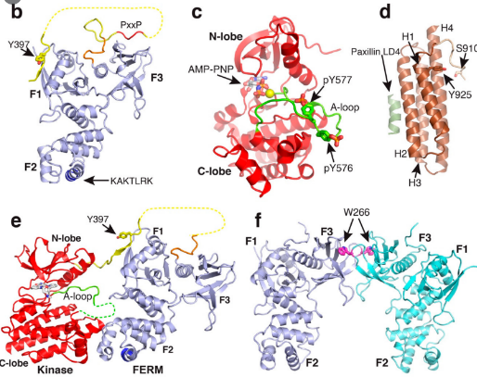

**Alpha: 8 Helix**

**F1: 3,F2: 4,F3: 1**



**8α-helix (Globin fold)**



**α -helix**

**Four Alpha helix bundle**

**(αααα)**



**Domain 1 (RED): 8 Alpha Helix**

**Domain 2 (PURPLE): 8 Alpha Helix**

**F1: 3,F2: 4,F3: 1**



**Domain 1 (PURPLE): 8 Alpha Helix**

**F1: 3,F2: 4,F3: 1**

**Domain 2 (Sky blue): 8 Alpha Helix**

**F1: 3,F2: 4,F3: 1**